WELCOME TO THE BARRINGTONS!
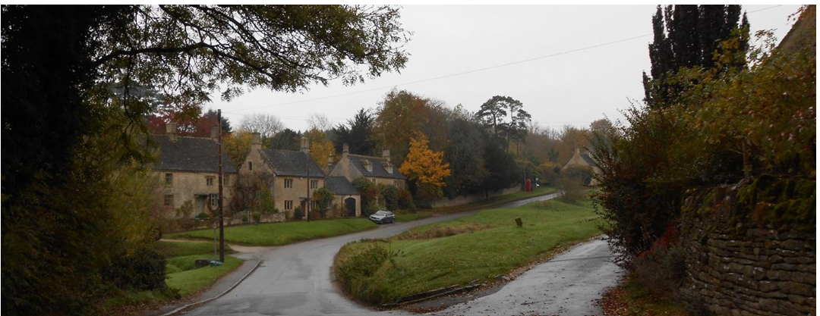
We are so glad you have chosen our community as your next home. The villages of Little and Great Barrington have a rich history, natural beauty, a variety of activities, and easy connections to major towns and cities. We want to share a few basic bits of information with you as you settle into our villages.
*If you wish to be kept abreast of local events and activities, including parish council meetings, please send your email to clerk@barringtonglos-pc.glos.uk
Village WhatsApp Groups Keep up to date on events, local news/traffic, and other village matters. Please send a message to Jacky King for Little Barrington (Buzzing Little B) on 07894 162638. For Great Barrington, please Lynn Gorton at lynn@barrington-park.co.uk.
We also have a Facebook group for the Parish Council. It can be found here: https://www.facebook.com/barrington.parishcouncil.

Church Services
Church Services take place in one of the five churches in the Windrush Benefice (Aldsworth, Great Barrington, Little Barrington, Sherborne and Windrush) every Sunday.
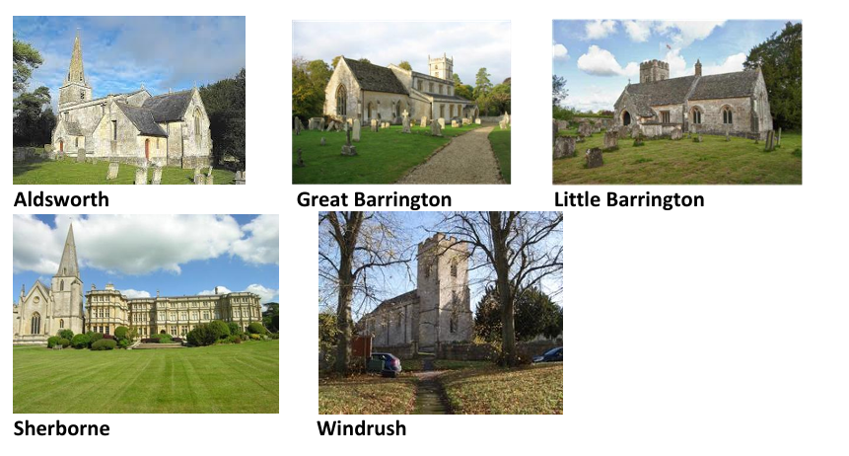
The Church of St Peter’s in Little Barrington usually has a service of Morning Prayer or Holy Communion every second Sunday of the month.
The Church of St Mary's in Great Barrington is now repaired. All services are posted on the notice boards outside our churches, and on the Benefice website https://windrushbenefice.weebly.com/

The church welcomes all and is always grateful to any residents who may have time to volunteer. To get involved, please contact any of the Parochial Church Council (“PCC”). To subscribe to Windrush Benefice’s “pEw News” for news around the benefice, please send an email to windrushcurate@proton.me

Barrington’s Book Club
The book club meets once every 4-8 weeks, with a different member of our group hosting and choosing the book to read. We always have a good laugh and enjoy a bit of socialising. All are welcome – even if you don’t manage to read the book! To get involved, please contact Karla Leahy (Little Barrington) on 07887 732270.

Booking the Great Barrington Village Hall
Alternatively, Great Barrington village hall is available to hire for larger functions. The main hall comfortably seats 100 at tables without being too cramped, whilst still allowing room for dancing and a bar area. Contact Lynn Gorton, Estate Secretary at Barrington Park Estate for further details. 01451 844306, lynn@barrington-park.co.uk

Annual activities
We have a range of activities throughout the year, with the aim of bringing together the whole community. Here are just a few
Date | Name of Event | Where | Who to Contact
September | Strim, Stream, and  Soup | Little Barrington 26/09/2026 | Cllr Jan de Haldevang
November | Autumn Litter Pick | Barringtons 07/11/2026 09.30 | Cllr Ali Hope
December | Advent drinks | Little Barrington  05/12/2026 | Cllr Jan de Haldevang
See the exact dates each year on the parish council website –

Your Parish Council
The job of the Parish Council is to represent the interests of the whole community on issues such as planning, highways, traffic, community safety, litter and rights of way and, when necessary, present the community views to the Cotswold District Council or Gloucestershire County Council. Below are the parish councillors and how to contact them:

Councillor | Email | Telephone
Jan de Haldevang | Jan.de.haldevang@barringtonglos.pc.gov.uk | 07748 692691
Richard Wingfield | Richard.Wingfield@barringtonglos.pc.gov.uk | 07768 991828
Ali Hope | Ali.Hope@barringtonglos.pc.gov.uk | 07768 584920
Iain Lyall | Iain.Lyall@barringtonglos.pc.gov.uk | 07506 015425

Other representatives:
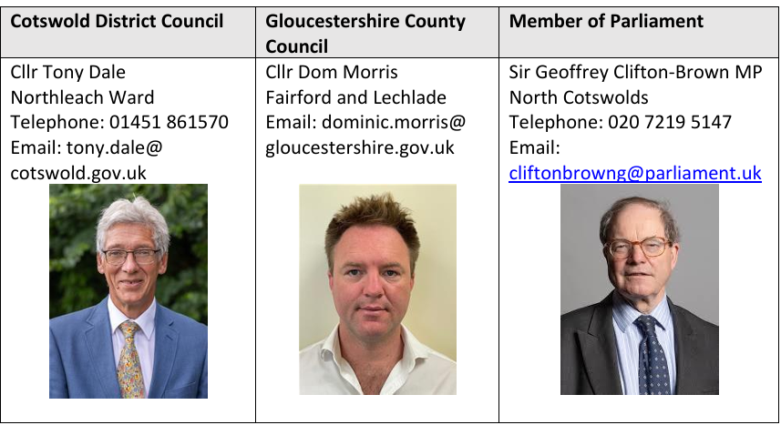

Bin collections
See this link for details: https://www.cotswold.gov.uk/bins-and-recycling/check-your-collection-day/

Neighbourhood Watch Team
Little Barrington | Great Barrington | Great Barrington
sclealuk@btinternet.com | venetiacd@yahoo.co.uk | venetiacd@yahoo.co.uk
07799 344771 | 01451 844586 | 01451 844586

It is useful for continuing NHS care that new Barrington residents may choose Gloucestershire or Oxfordshire NHS Trusts.

GP Practices and Hospitals:

Oxfordshire NHS
Local GP Practice Burford Surgery, 59 Sheep Street, Burford OX18 4LS, Phone: 01993 822176

Witney Community Hospital, Welch Way, Witney
* Minor Injuries Unit, 10:00 - 22:30, every day. Phone: 01865 903841

John Radcliffe Hospital, Headley Way, Oxford, OX3 9DU.
Phone: 0300 3047777 * Emergency Department, Open 24 Hrs.

Gloucestershire NHS
Cotswold Medical Practice, Westwoods Surgery, 30 Basset Road, Northleach GL54 3QJ
Cotswold Medical Practice, Moore Health Centre, Moore Road, Bourton-on-the-Water GL54 2AZ

North Cotswolds Hospital, Moreton-in-Marsh, GL56 0DS. Phone: 0300 421 8770 * Minor Injuries Unit, 0800 - 19:30 hours every day

Cheltenham General Hospital, Sandford Road: GL53 7AN: Phone 0300 422 2222 * Emergency Department, Open 24 Hours

Nearest Chemists – Reavley Chemist, 124 High Street, Burford, OX18 4QR Phone: 01993 823144

Badham Pharmacy, The Village Square, Upper Rissington, GL54 2FL
Phone: 01451 828226

Nearest Veterinary Surgery
Dragons Vets, 8A-8B Sopwith Rd, Upper Rissington, GL54 2NL
Phone: 01451 600891

Defibrillators
In Little Barrington, it is in the red telephone box just opposite The Green.
In Great Barrington, it is in the red telephone box on the main road.

Taxis / Mini-cab Wychwood Taxis, Tel 07756 669744

Burford Private Hire – run by a friendly man called Steve: bookable in advance only, via 01993 822209 or burfordprivatehire@gmail.com

Additionally, Uber is now operating in the area, although immediate availability can be patchy and booking ahead is advisable.

We hope you enjoy your new life in the Barringtons, and we look forward to meeting you soon.

Contact List
ORGANISATION | TELEPHONE NUMBER | WEBSITE
EMERGENCY SERVICES
Emergency Services (if life is at risk) | 999
Fire & Rescue (non-emergency): | 01452 753 333
Police (non-emergency): | 101 | www.gloucestershire.police.uk
Medical Support (non-emergency): | 111

LOCAL AUTHORITIES
Gloucestershire County Council | 01452 425 000 Emergency only: 08000 921 776 | www.gloucestershire.gov.uk
Cotswold District Council | 01285 623 000 Emergency out of hours 01865 742138 | www.cotswold.gov.uk
Gloucestershire Highways | 08000 514 514 | www.gloucestershire.gov.uk/highways

GENERAL A – Z
Association of British Insurers | 020 7600 3333
BBC Radio Gloucestershire: (104.7, 95.0, 95.8 FM, 1413AM) | 01452 308585 | www.bbc.co.uk/gloucestershire
Crimestoppers | 0800 555 111
Citizens Advice | 020 7833 2181 | www.citizensadvice.org.uk
Electricity Faults | 0800 328 1111
Environment Agency | General Enquiries 08708 506 506 Floodline  0845 988 1188 | www.environmental-agency.gov.uk
Furniture Recycling Project | 01452 302 303 | www.frpglos.org.uk
Gas leaks | 0800 111 999 | www.nationalgrid.com
Gloucestershire Community Foundation | 01452 656 385 | www.gloucestershire communityfoundation.co.uk
Gloucestershire County Council Trading Standards | 08454 040506 | www.tradingstandards.gov.uk/glos

Gloucestershire Primary Care Trust | 08454 221500 | www.glospct.nhs.uk
Gloucestershire Rural Community Council | 01452 528491 | www.grcc.org.uk
Health Protection Agency | 01453 829650 | www.hpa.org.uk
National Flood Forum | 01299 403 055 | www.floodforum.org.uk
NHS Direct | 111 | www.nhsdirect.nhs.uk
Red Cross | 01452 726 660 | www.redcross.org.uk
Royal Institute of Chartered Surveyors (RICS) | 020 8207 6100 | www.ricsfirms.com
Samaritans | 08457 90 90 90 | www.samaritans.org
St John’s Ambulance | 01452 858220 | www.sja.org.uk
Thames Water | 0845 9200 800 | www.thameswater.co.uk
Village Agents in Gloucestershire | 01452 528 491 | www.grcc.org.uk/ourwork/village _agents

BARRINGTON PARISH CONTACT LIST
Organisation | Who to Contact | Phone Nos | Details
Barrington Parish Council | See “Your Parish Council” above. |  | www.barringtonglos-pc.gov.uk
Great Barrington Church | Richard Crosbie Dawson | 07979 536404 | richard@cdawson.co.uk
Little  Barrington Parochial Church  Council (“PCC”) (as at April 2026) | Chairman Rev Jan H de Haldevang | 01451 844 613 | windrushcurate@proton.me
 | Church Warden:  Dean Baker | 07930 840267 | deanbaker@outlook.com
 | Secretary:  Karla Leahy | 07887 732270 | karla.leahy@googlemail.com
 | Treasurer: Jacky King | 07894 162 638 | jackyking@btinternet.com
 | Jane Ruthven | 01451 844 337 | janeruthven@icloud.com
 | Benefice Website |  | www.windrushbenefice.weebly.com
Barrington Park Estate Office |  | 01451 844 306
Little Barrington Village Hall  Reading Room | Alex Pierre-Traves | 0781  7924224 | apt773@yahoo.com ???????
Great Barrington Village Hall | Barrington Park Estate Office | 01451 844 306
Windrush Valley Flower  Show | Claire Thorpe | 07810 005624 |  | claireethorpe@gmail.com  windrushvalleyflowershow@gmail.com

